Website: Title Waves | Home
File path: php.kkc.school.nz/12DGT/ch20171/Y12/Term 1 Assessment/

Database Designing - draw.io
Wireframes - draw.io

Queries and corresponding SQL

Homepage.php Queries
/* -------------------------------------------------------------------------------------------------
Build UNION of genre tables where rating_count > 100 and pick unique ISBNs ordered by rating
--------------------------------------------------------------------------------------------------*/
$genres = get_valid_genres();
$parts = array();
foreach ($genres as $g) {
$safe = $conn->real_escape_string($g);
$parts[] = "SELECT *, '$safe' AS genre FROM `$safe` WHERE rating_count > 100";
}
$sql = implode(" UNION ALL ", $parts) . " GROUP BY ISBN ORDER BY rating DESC, rating_count DESC";
Explanation:
The purpose of this query is to return books that are highly rated (rating_count > 100) and return unique ISBN’s ordered by the books rating.
- Loops through every genre table and selects all the columns
- Adds a new column called ‘genre’ that represents the table the entry is from.
- Filters to books with a rating count of over 100
- Unions all the SELECT queries and groups them by ISBN to prevent duplicates
- The result is then ordered by rating
(If a result has the same rating the two results will be placed in descending order of rating count)
The query is passed into the carousel function so the website can create a carousel showing the results

Browse.php Queries
$search_query = isset($_GET['query']) ? trim($_GET['query']) : '';

/* -------------------------------------------------------------------------------------------
Build union query. If searching, restrict WHERE; otherwise show frequently-rated books.
--------------------------------------------------------------------------------------------*/
$genres = get_valid_genres();
$union_parts = array();
foreach ($genres as $g) {
$safe_table = $conn->real_escape_string($g);
if ($search_query !== '') {
$q = $conn->real_escape_string($search_query);
$union_parts[] = "SELECT *, '$safe_table' AS genre FROM `$safe_table` WHERE title LIKE '%$q%' OR author LIKE '%$q%' OR categories LIKE '%$q%'";
} else {
$union_parts[] = "SELECT *, '$safe_table' AS genre FROM `$safe_table` WHERE rating_count > 100";
}
}

$sql = implode(" UNION ALL ", $union_parts) . " GROUP BY ISBN ORDER BY title ASC";
Explanation:
This query is used on the Browse page to show the user results related to their search.
Alternatively if there is no search, the query will show the same highly rated books as the homepage.
- Loops through every genre table and selects all the columns
- Adds a new column called ‘genre’ that represents the table the entry is from.
- Filters to books with a rating count of over 100
- Unions all the SELECT queries and groups them by ISBN to prevent duplicates
- The result is then filtered to show results where the title, author, or category is like the search article.
The query is passed into the carousel function so the website can create a carousel showing the results

Book.php Queries
/* ----------------
Fetch book
-----------------*/
$sql = "SELECT * FROM `$safe_genre` WHERE ISBN = '$safe_isbn' LIMIT 1";
$result = $conn->query($sql);
if (!$result || $result->num_rows === 0) {
die("Book not found.");
}
$book = $result->fetch_assoc();
Explanation:
This query is used on the Books page to fill out important fields in the page, eg. Category, ISBN, Price etc.
- When the user clicks a book the page is given two pieces of information:
  - It’s genre (this also functions as its table name)
  - it’s ISBN
- The info the page is provided will be used in the query to select results in the genre its from where the ISBN matches
- This query is limited to showing one result to ensure we don't get provided two duplicate book results
/* -------------------------------------------------------
Related books by same author (unique ISBNs, limit)
--------------------------------------------------------*/
$author_safe = $conn->real_escape_string($book['author']);
$parts = array();
foreach (get_valid_genres() as $g) {
$safe_table = $conn->real_escape_string($g);
$parts[] = "SELECT *, '$safe_table' AS genre FROM `$safe_table` WHERE author = '$author_safe' AND ISBN != '$safe_isbn'";
}
$related_sql = implode(" UNION ALL ", $parts) . " GROUP BY ISBN ORDER BY title ASC LIMIT 12";
$related_result = $conn->query($related_sql);
Explanation:
This query is used to find other books written by the author of the book the user is viewing.
- The query will find the authors name using the result found in the pages other query
- Loops through every genre table and selects all the columns
- Adds a new column called ‘genre’ that represents the table the entry is from
- Filters to results where the author is the same as the book the user is currently viewing and the ISBN is different.
- Unions all the SELECT queries and groups them by ISBN to prevent duplicates
- The result should be ordered alphabetically by the book titles.
- The result is also limited to only 12 results to keep it short
The query is passed into the carousel function so the website can create a carousel showing the results

Create_Order.php Queries
$ID = get_logged_in_customer();

/* ---------------------------------------------------------------------------
fetch historical orders (join with union of genres to get title/price)
----------------------------------------------------------------------------*/
$genres = get_valid_genres();
$union_books = array();
foreach ($genres as $g) {
$safe = $conn->real_escape_string($g);
$union_books[] = "SELECT '$safe' AS genre, title, ISBN, price FROM `$safe`";
}
$books_union_sql = implode(" UNION ALL ", $union_books);

$sql = "
SELECT o.order_date, o.ISBN, o.Qty, b.title, b.price, b.genre
FROM Orders o
JOIN ( $books_union_sql ) b ON o.ISBN = b.ISBN
WHERE o.ID = ?
ORDER BY o.order_date DESC
";
$stmt = $conn->prepare($sql);
$stmt->bind_param("i", $ID);
$stmt->execute();
$orders_result = $stmt->get_result();
$stmt->close();
Explanation:
This query is used to show orders created by the logged in user.
- Loops through every genre table and selects all the columns.
- Adds a new column called ‘genre’ that represents the table the entry is from.
- The query then joins the table to the orders table via ISBN.
- Selects the ISBN, Quantity, Title, Price, and genre of each result where the ID matches the logged in users ID.
- The result is then ordered by the order date.
The result of the query is then formatted into an HTML table for the user to view.

Customer_Portal.php Queries
/* -------------------------------------------------
LOGIN
--------------------------------------------------*/
if ($action === "login") {
$phone = trim($_POST["phone"]);
if (empty($phone)) {
$error = "Please enter your phone number.";
} elseif (!preg_match("/^[0-9]{9}$/", $phone)) {
$error = "Phone number must contain exactly 9 digits.";
} else {
$stmt = $conn->prepare("SELECT `ID`, `First Name`, `Last Name` FROM Customers WHERE Phone = ?");
$stmt->bind_param("s", $phone);
$stmt->execute();
$result = $stmt->get_result();

if ($result->num_rows === 1) {
$row = $result->fetch_assoc();
$_SESSION['ID'] = (int)$row['ID'];
$_SESSION['customer_name'] = $row['First Name'] . ' ' . $row['Last Name'];
header("Location: homepage.php");
exit();
} else {
$error = "No account found with that phone number.";
}
$stmt->close();
}
}
Explanation:
This query is used to log the user into their account via creating a php session for the user.
- Validates the phone number.
(ensure it is 9 digits and exists in the customers table).
- The program can do two things at this point:
  - If a matching phone number is found, the user will be logged in.
  - If there is no matching phone number, the user will be shown an error.
/* -------------------------------------------------
SIGNUP
--------------------------------------------------*/
if ($action === "signup") {
$first = trim($_POST["first_name"]);
$last = trim($_POST["last_name"]);
$address = trim($_POST["address"]);
$suburb = trim($_POST["suburb"]);
$postcode = trim($_POST["postcode"]);
$phone = trim($_POST["phone"]);
$newsletter = isset($_POST["newsletter"]) ? 1 : 0;

if (empty($first) || empty($last) || empty($address) || empty($suburb) || empty($postcode) || empty($phone)) {
$error = "All fields except newsletter must be filled in.";
} elseif (!preg_match("/^[0-9]{9}$/", $phone)) {
$error = "Phone number must contain exactly 9 digits.";
} elseif (!preg_match("/^[0-9]{3}$/", $postcode)) {
$error = "Postcode must contain exactly 3 digits.";
} else {

// Check if phone number already exists
$stmt = $conn->prepare("SELECT ID FROM Customers WHERE Phone = ?");
$stmt->bind_param("s", $phone);
$stmt->execute();
$exists = $stmt->get_result();
$stmt->close();

if ($exists->num_rows > 0) {
// Duplicate phone — stop signup
$error = "An account with that phone number already exists.";
} else {
// Phone is unique — continue with signup
$signup_date = date('Y-m-d H:i:s');

$stmt = $conn->prepare("
INSERT INTO Customers (`signup_date`, `First Name`, `Last Name`, `Address`, `Suburb`, `Post Code`, `Phone`, `newsletter`)
VALUES (?, ?, ?, ?, ?, ?, ?, ?)
");
$stmt->bind_param("sssssiis", $signup_date, $first, $last, $address, $suburb, $postcode, $phone, $newsletter);

if ($stmt->execute()) {
$new_id = $stmt->insert_id;
$_SESSION['ID'] = $new_id;
$_SESSION['customer_name'] = $first . ' ' . $last;
$success = "Account created successfully! Welcome, $first!";
header("Location: homepage.php");
exit();
} else {
$error = "Error creating account: " . htmlspecialchars($stmt->error);
}
$stmt->close();
}
}
}
Explanation
This query is used to insert new customers into the customers table and log the new user into a php session.
- The query will first validate these two fields:
  - Phone number
  - Post code
- The query will then check if the phone number already exists.
The signup process will stop and an error will be thrown if the phone number already exists.
- If all the fields so far have been valid the new user will have their info inserted into the customers table and log them in automatically

Reports.php Queries
/* -------------------------------------------------
Build UNION for prices (ISBN + price)
Books purchased by customer
--------------------------------------------------*/
$union_prices_parts = [];
foreach (get_valid_genres() as $g) {
$safe = $conn->real_escape_string($g);
$union_prices_parts[] = "SELECT ISBN, price FROM `$safe`";
}
$union_prices_sql = implode(" UNION ALL ", $union_prices_parts);

$books_by_customer_sql = "
SELECT
c.`First Name` AS fname,
c.`Last Name` AS lname,
SUM(o.Qty) AS books_purchased,
SUM(p.price * o.Qty) AS total_value
FROM Customers c
JOIN Orders o ON c.ID = o.ID
JOIN (
SELECT ISBN, MAX(price) AS price
FROM (" . $union_prices_sql . ") AS prices
GROUP BY ISBN
) p ON o.ISBN = p.ISBN
GROUP BY c.ID
ORDER BY total_value DESC
";
$books_by_customer = $conn->query($books_by_customer_sql);
Explanation:
This query is used on the Reports page to show the number of orders placed by each customer as well as the total amount spent per customer.
- Builds a union of all the book tables, selecting the ISBN and price.
- Joins the Customers table to Orders via the customers ID
(new table will contain the customer data, connected to each of their purchases)
- Joins the new table to the Isbn and Price table (joined via ISBN).
(If duplicate ISBN’s are present it will use the higher price of the two).
- Gets the total amount of money spent by the user as well as the total amount of books the user has purchased.
- Then sorts the results by the amount spent (descending order).
After the query is complete the data will be passed into a HTML table for the admin to view.

Result:
fname | lname | books_purchased | total_value
Foo | Bar | 5 | 100.00

/* -------------------------------------------------
Build UNION for prices (ISBN + author + price)
Sales by author
--------------------------------------------------*/
$union_author_parts = [];
foreach (get_valid_genres() as $g) {
$safe = $conn->real_escape_string($g);
$union_author_parts[] = "SELECT ISBN, author, price FROM `$safe`";
}
$union_author_sql = implode(" UNION ALL ", $union_author_parts);

$sales_by_author_sql = "
SELECT
b.author,
SUM(o.Qty) AS total_books,
SUM(b.price * o.Qty) AS total_value
FROM Orders o
JOIN ( $union_author_sql ) b ON o.ISBN = b.ISBN
GROUP BY b.author
ORDER BY total_value DESC
";
$sales_by_author = $conn->query($sales_by_author_sql);
Explanation:
This query is used on the Reports page to show the number of orders placed by each customer as well as the total amount spent per customer.
- Builds a union of all the book tables, selecting the ISBN, author, and price.
- Joins the Orders table to the table created during the first query via ISBN.
(Uses the highest price associated with that ISBN if duplicates present)
- Gets the total amount of money earnt by this author as well as the total amount of books they have sold.
- Then sorts the results by the amount spent (descending order).
After the query is complete the data will be passed into a HTML table for the admin to view.

Result:
author | total_books | total_value
Foo | 5 | 100.00

/* -------------------------------------------------
Newsletter groups
--------------------------------------------------*/
$newsletter_customers = $conn->query("
SELECT `First Name` AS fname, `Last Name` AS lname, Address, Phone
FROM Customers
WHERE newsletter = 1
");

$non_newsletter_customers = $conn->query("
SELECT `First Name` AS fname, `Last Name` AS lname, Address, Phone
FROM Customers
WHERE newsletter = 0
");

Explanation:
These queries are used on the Reports page to show the customers that are, and are not signed up to the newsletter based on the boolean newsletter values from the customer table.

Final Database Design:
Go to the designer tab of your database and take a screenshot of your database.
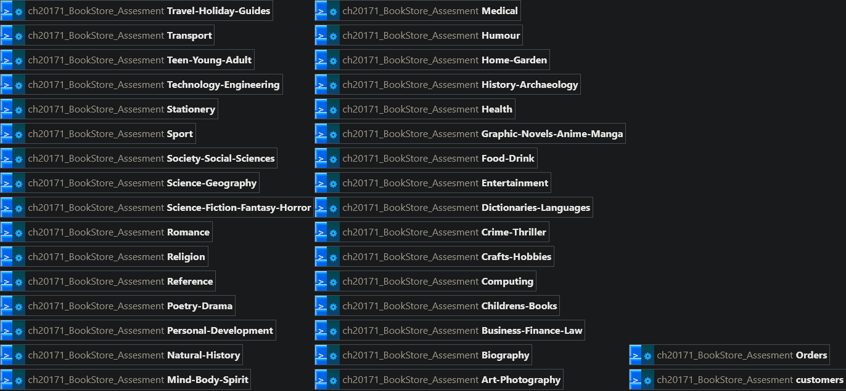

Relevant Implications
In addition to the design you will need to describe and explain the relevant implications and how your database will address these implications.
Implication | Why they need to be considered | What you have done to address them.
Social | The quality of the system affects how people interact with the store and with each other.  A poor experience might isolate users and/or discourage their engagement with the website. | - Clear consistent navigation.  - Cart system to align with standards across other shopping websites.  - Search bar to allow users to find books without crawling through the entire database.  - Login/Logout processes that are easy enough to follow.
Cultural | Books are for a wide variety of audiences, so the website should avoid excluding or misrepresenting other cultures. | - Neutral and professional language.  - Genre list handles a wide variety of genres without bias.
Legal | This site handles customer data, “transactions”(transactions in quotes because i can't justify actually adding a way to pay), and copyrighted materials.  This means that privacy laws apply. | - Password/login system to ensure access is limited to the correct people.  - Orders are inserted with prepared statements to ensure no SQL injection occurs (legal risk if breached)  - No copyrighted data should be shown to the user, only book covers and related data eg. Title, author, genre etc.
Ethical | The system should behave predictably, treating the customer with respect.  Eg. ensuring their data is safe. | - Users must be logged in to make purchases (prevents fraudulent purchases).  - Admin features are restricted to the admin account.  - Prices cannot be manipulated by the customer and are instead pulled from the database.  - All actions are very intentional, nothing occurs in the background without the user's knowledge.
Intellectual Property | Books covers, descriptions, and titles might be copyrighted.  Using them incorrectly could violate copyright laws | - The site only stores book covers and related info.  - No book content previews are allowed beyond the book cover and its related info.  - (I don't actually own any of the rights to this stuff so how am i meant to justify this?)
Privacy | The system stores users' names, phone numbers, addresses, postcodes, etc.  Mismanagement of data could lead to data breaches and/or customer distrust. | - Sessions only store the users ID and name, no immediately sensitive info like addresses.  - Logout fully destroys the users session via session_destroy().  - The site is protected against SQL injection (to the best of my knowledge) via bind_param methods inside the checkout and other similar cases where it might be needed.  - No external analytics or tracking is used on the site.
Accessibility | All users should be able to use the site, whether they have a visual or cognitive impairment or they are simply viewing the site from a mobile platform. | - The use of Bootstrap ensures a responsive design that is accessible to all platforms.  - Buttons are large and high contrast.
Usability | A system that is poor in terms of usability frustrates users, which may reduce sales and user engagement. | - The website navigation is kept consistent through the use of a display_navbar() function.  - The search bar is always visible to the user to ensure the search functionality is always accessible to the users.  - The cart count badge constantly updates to show the cart's contents.  - Buttons are clearly labeled eg. View details, Add to cart, Remove.
Functionality | The site needs to reliably perform core tasks like browsing, ordering, logging in, and searching.  Poor functionality means poor operations for the Title Waves business. | - Process_post_actions ensures all cart logic is consistent across pages.  - Checkout_cart handles the transfer of the order to the database safely and creates separate orders for each item in the cart.  - Carousels are dynamically generated based on SQL results.  - The cart is completely stored in the session to reduce the load on the database.
Aesthetics | Attractive visual design means users are more likely to engage and trust the storefront. | - Clean bootstrap dark theme.  - Consistent use of cards for books.  - Plenty of spacing and clean typography with a responsive grid layout.  - Carousel controls are visually matched to the theme (as is pretty much everything else).
Sustainability and Future Proofing | The site should be easy to maintain and scale as the book stock and/ or customer base grows. | - Centralised database utilities ensure a reduction in repeat code.  - The genre list is stored in one place in db_utils.php.  - Uses prepared statements and sql unions making transitions between tables easier.  - Modular functions eg. cart, navbar, carousel make upgrades and transitions easier.  - The system should be able to scale to more genres or book tables with minimal changes
End-user Considerations | The system should meet users expectations and needs.  Customers need clarity, speed, and safety to have an enjoyable browsing experience. | - Logged in label assures users that they are on the correct account.  - Navbar buttons highlight the active page to ensure the user knows which page they are currently viewing.  - Error cases should be handled eg. no books found.  - Automatic page redirection after cart action ensures improved flow and that the user has a smooth browsing experience.  - Guest users can browse freely with the restriction of being unable to order books.
Health and Safety | Digital systems should avoid bringing harm to the users through things like scamming, fraud, and phishing. | - Sessions prevent the user from being impersonated as it stores the verified identity.  - User input is sanitized before being used in SQL queries to prevent SQL injection.  - The logout button is always clearly visible to prevent account sharing or accidental misuse of accounts.  - Book images always have a fallback to prevent broken UI confusion.

Testing
You should create a table to list all the tests you have done. You should explain what the expected inputs and outputs should be. Examples are:
All Queries working as expected
Website appears as intended (styling)
Handles unexpected inputs
Inserting Data
Explain what new features or refinements you will do based on your testing.
Expected Output: | Evidence:
Login/Logout, Valid credentials | 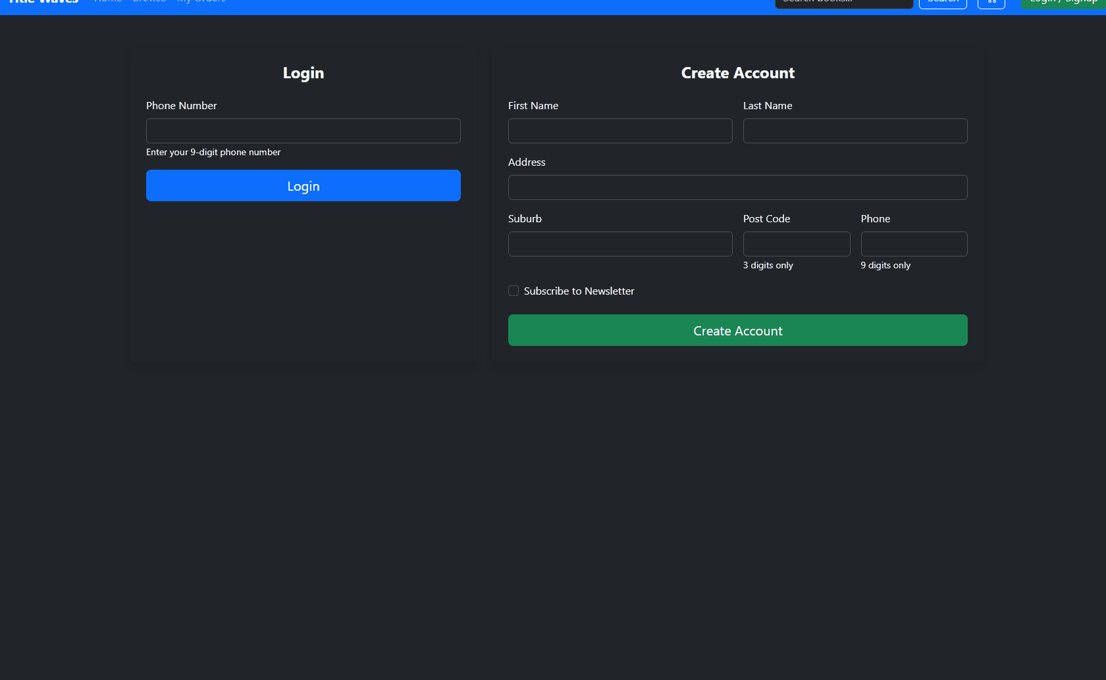
Login, Invalid credentials
Login, Empty fields | 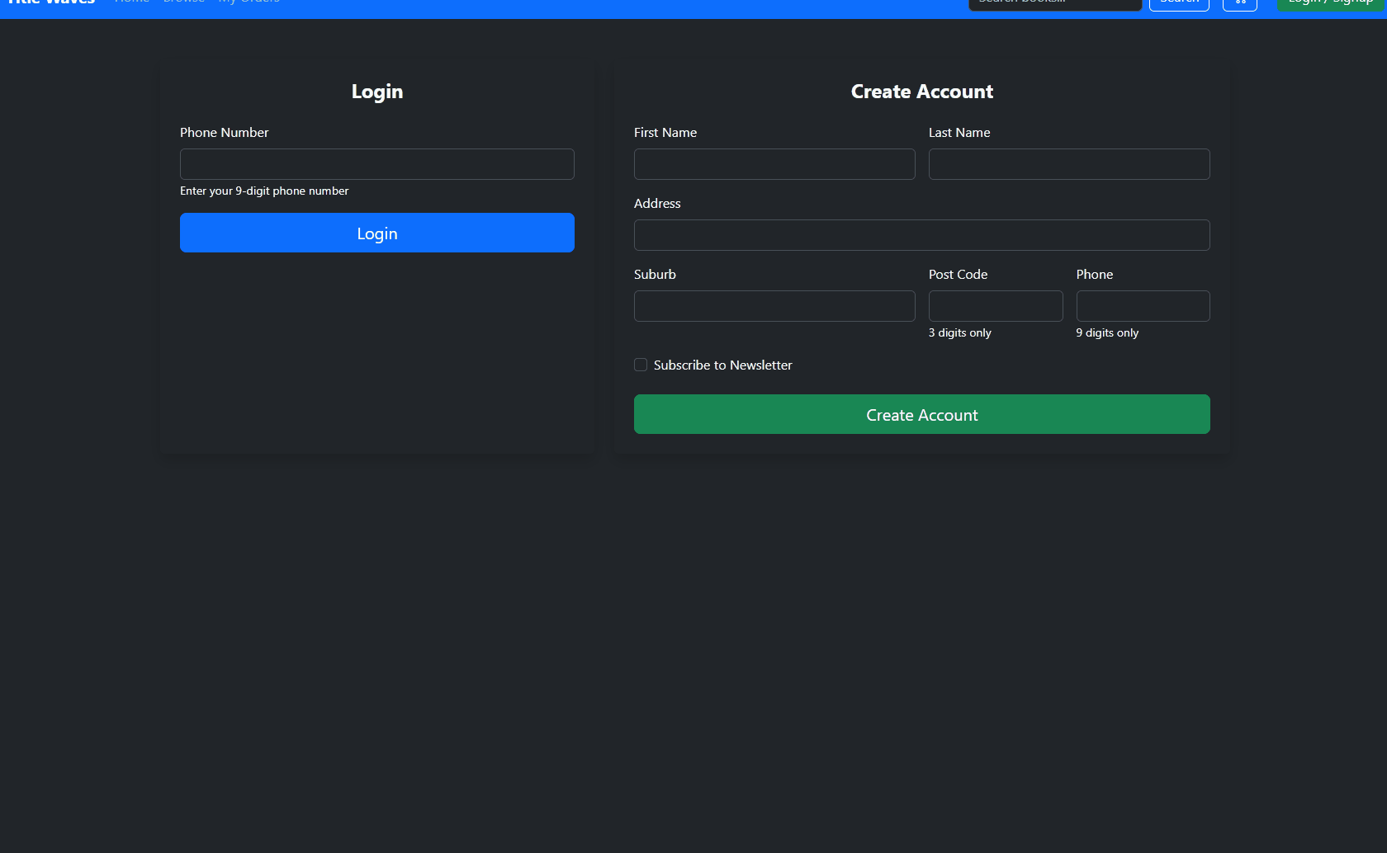
Signup, Valid credentials
Signup, Invalid credentials
Signup, Empty fields
Logout destroys session
returns to login screen
Restricted page requires login | 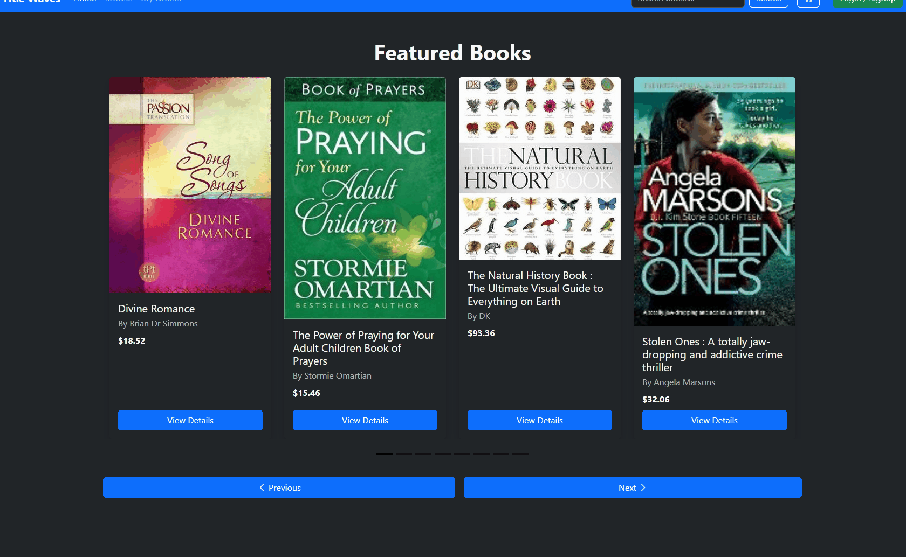
Carousels function correctly
Book cards link correct book page | 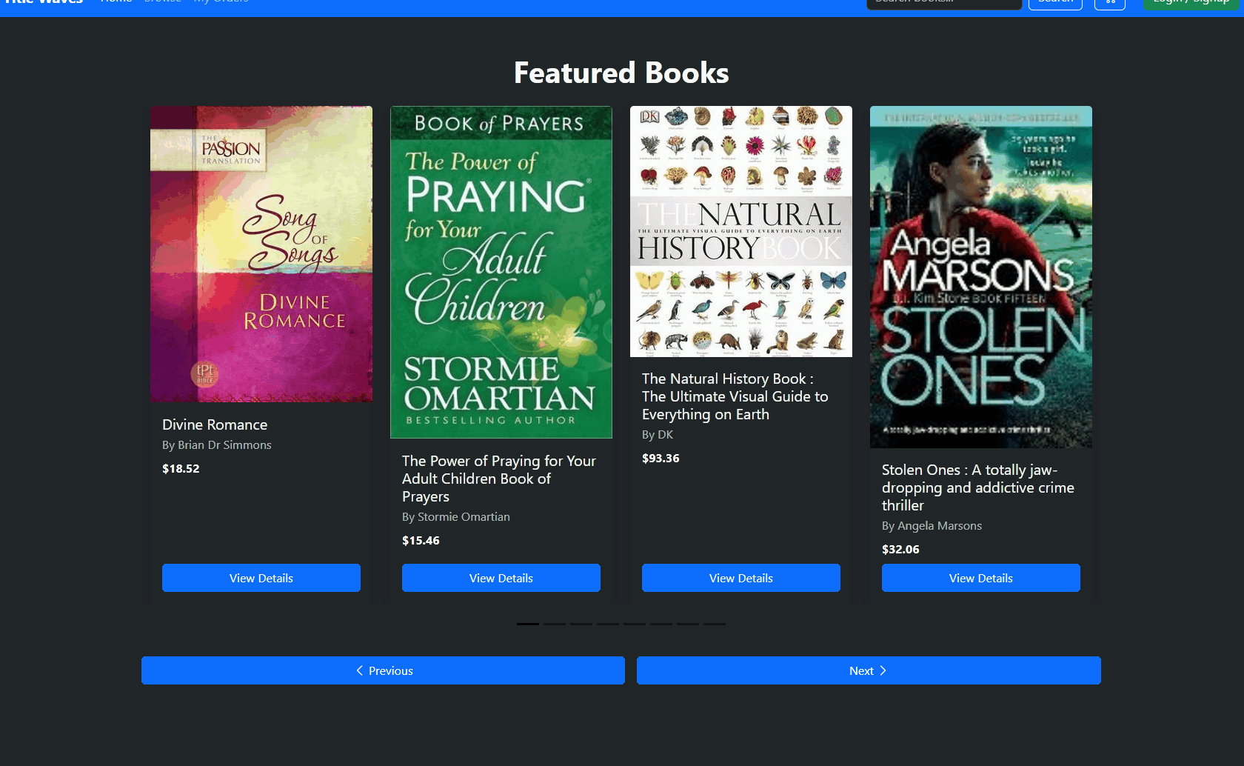
Search returns matching books
(Searched for “Foo” in gif)
No results search returns “no books found” | 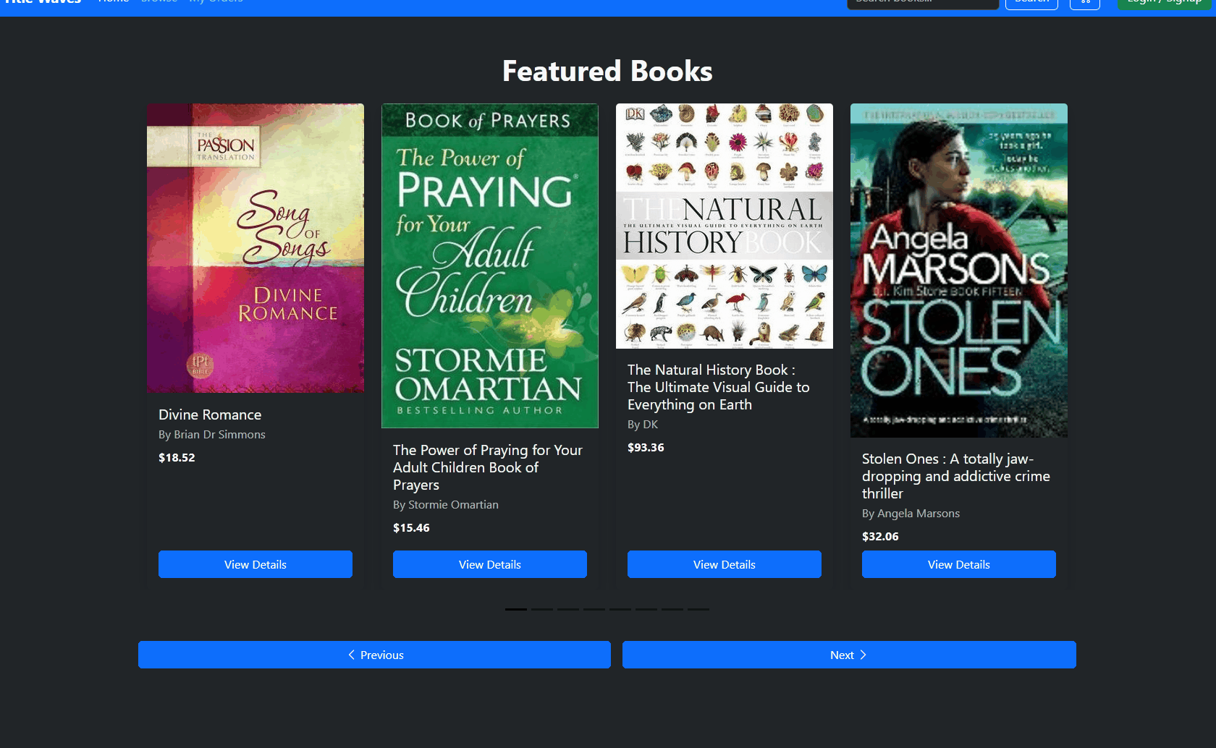
Adding item appears in cart | 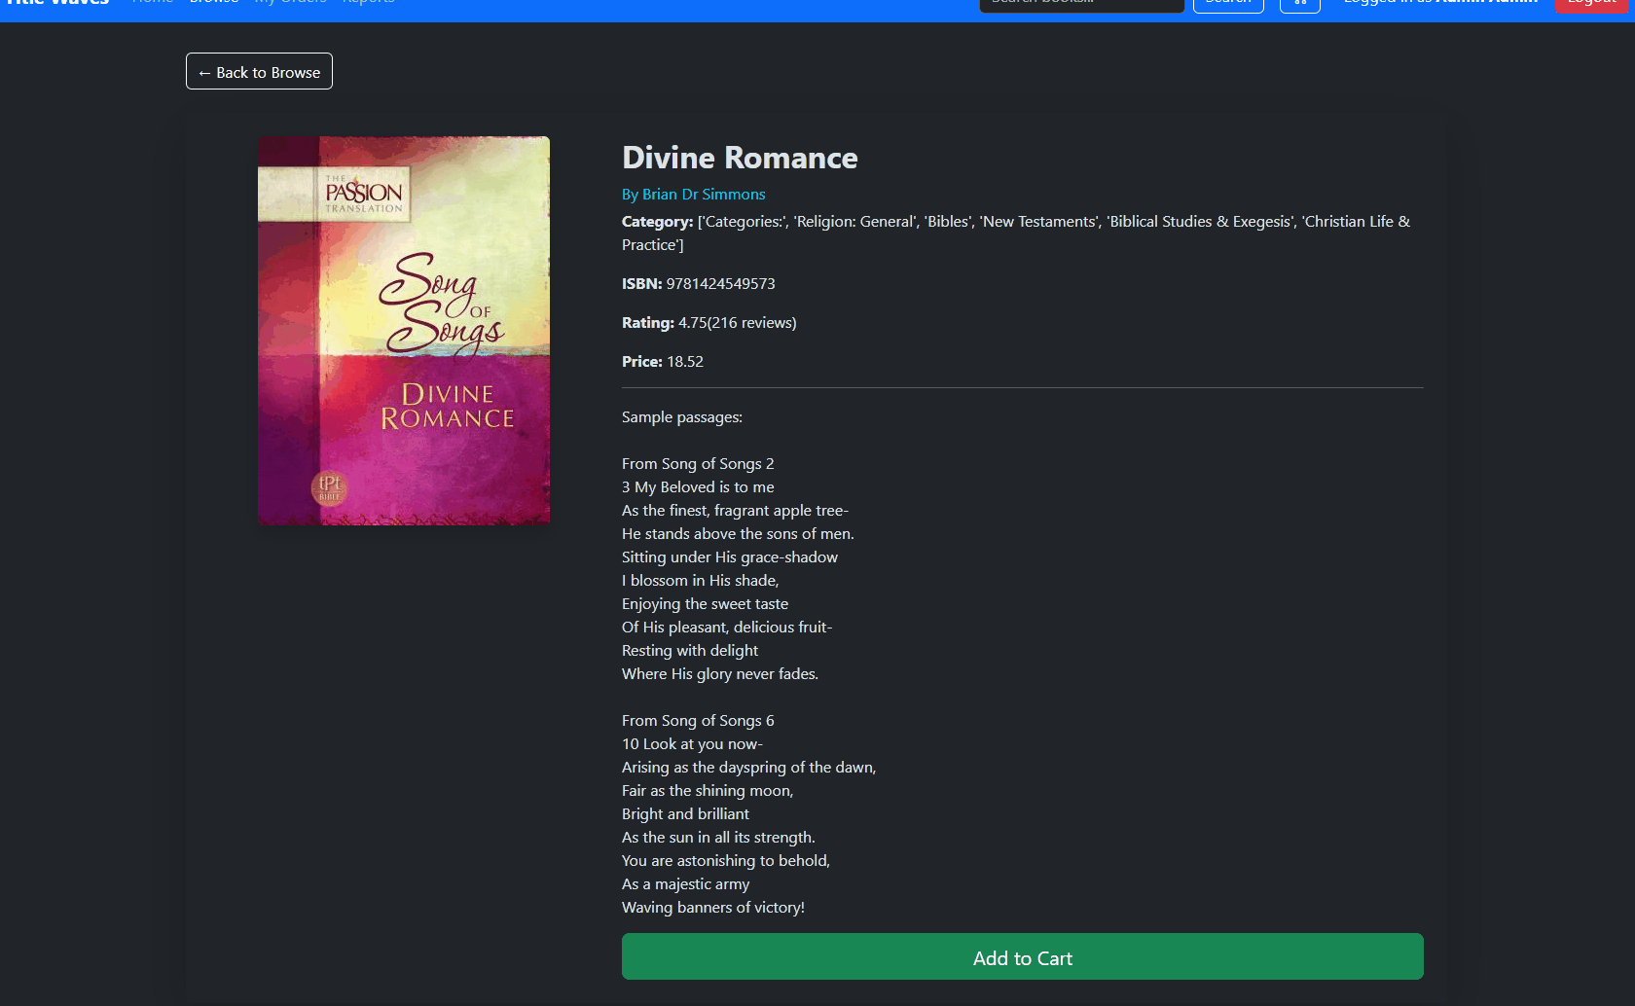
Adding same item increases QTY | 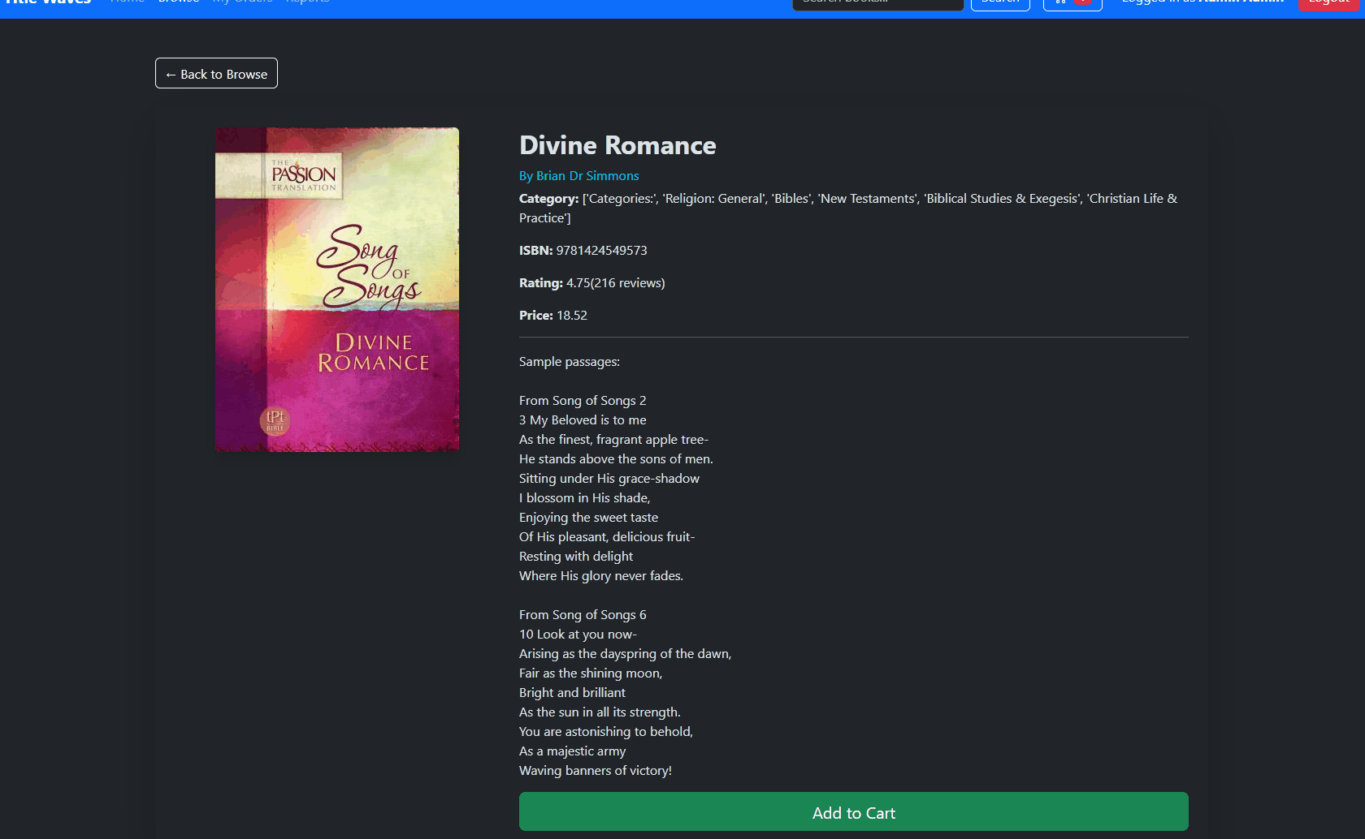
Removing unit decreases QTY | 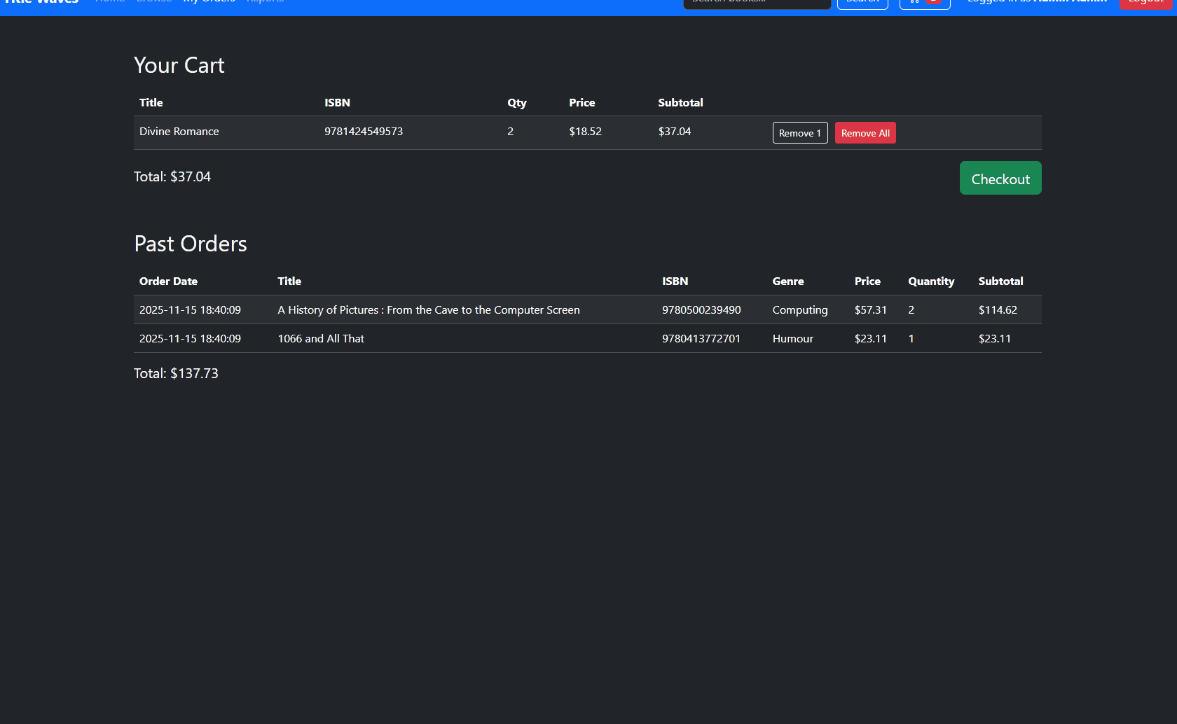
If Item QTY is 0 remove from cart | 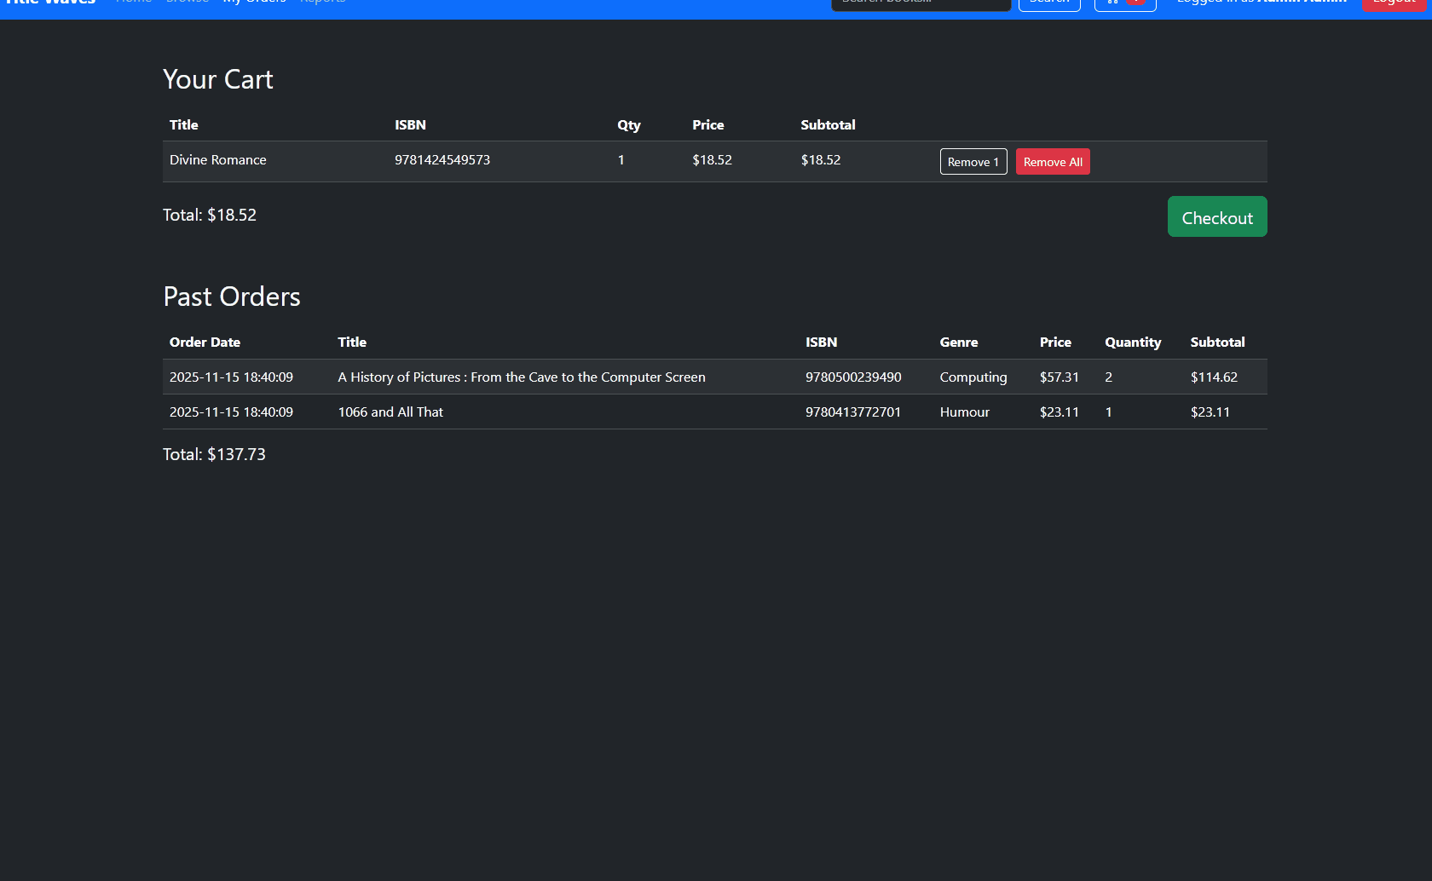
Cart count badge updates correctly | 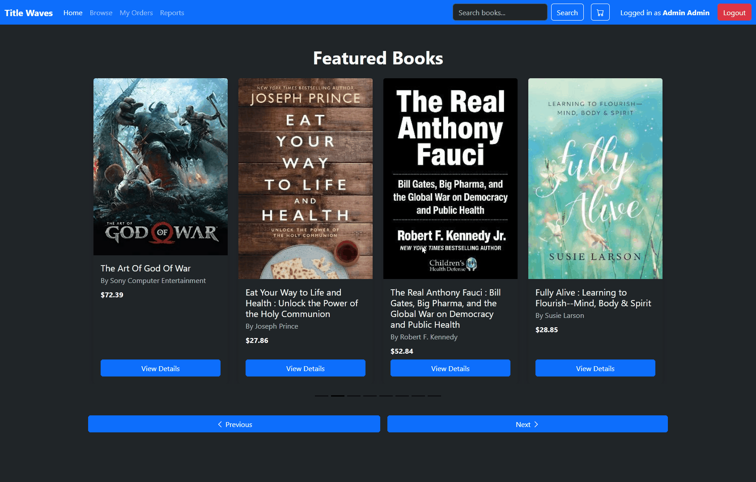
Cart persists until session closes | 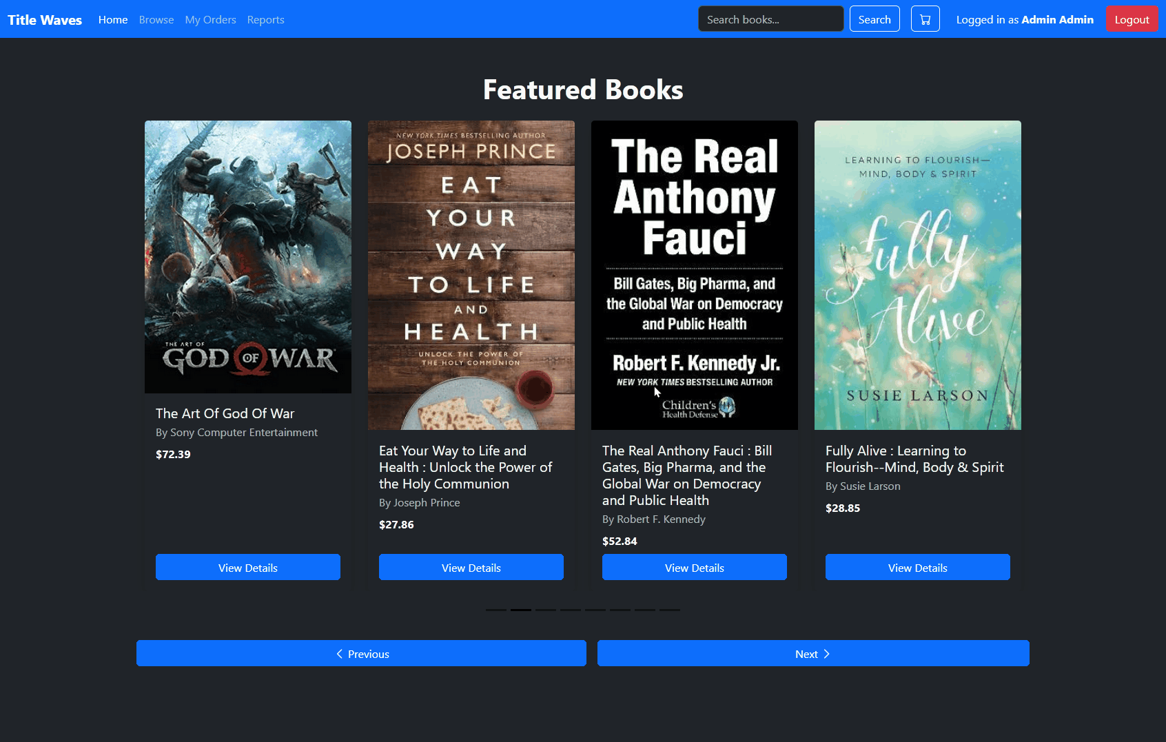
Checkouts work when logged in | 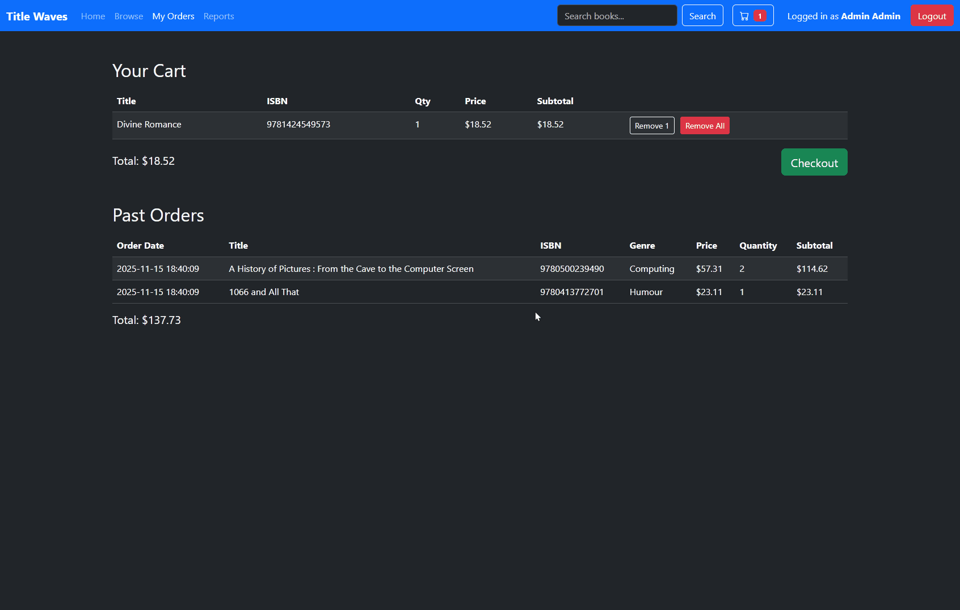
Checkouts do not work when logged out (redirected to login page) | 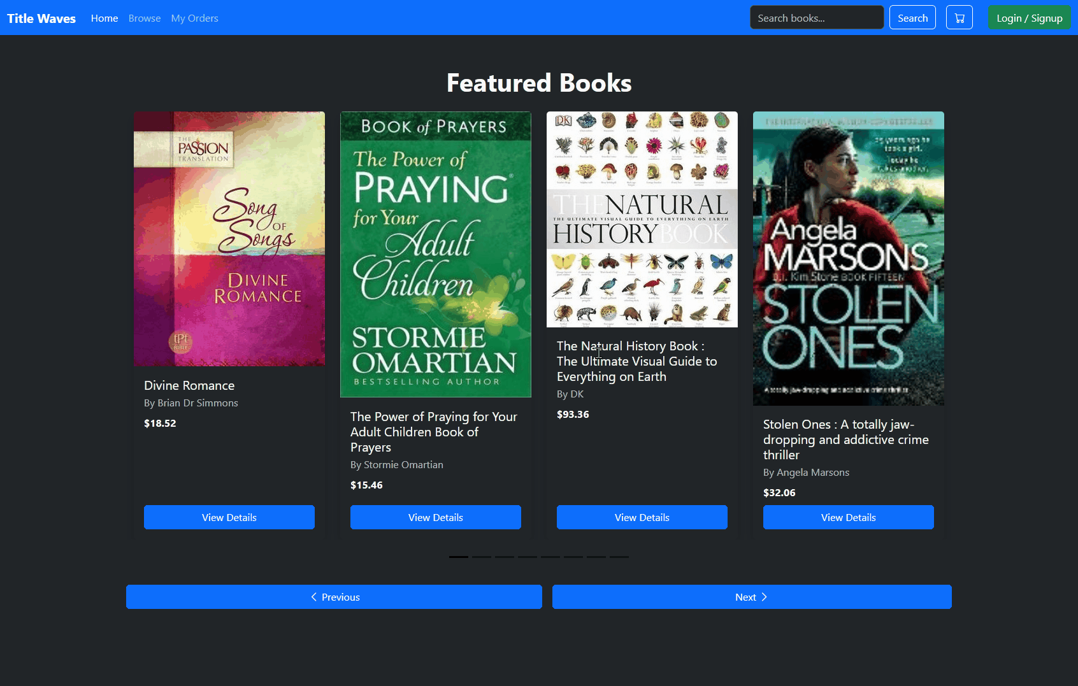
Cart is cleared after checkout
Orders are inserted into database correctly  (order highlighted is the order inserted in the previous entry) | 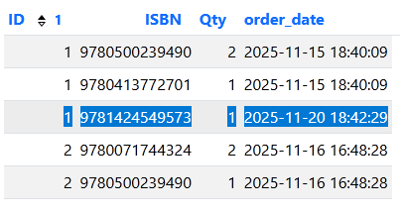
Reports page only visible for ID 1
Only admin can access reports  (redirect non-admins) | 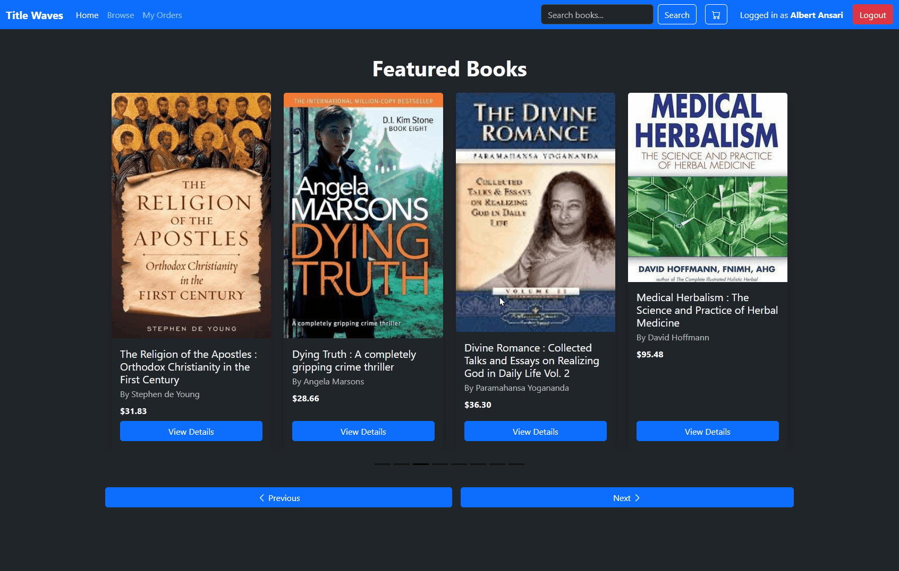
Reports load correct SQL data | 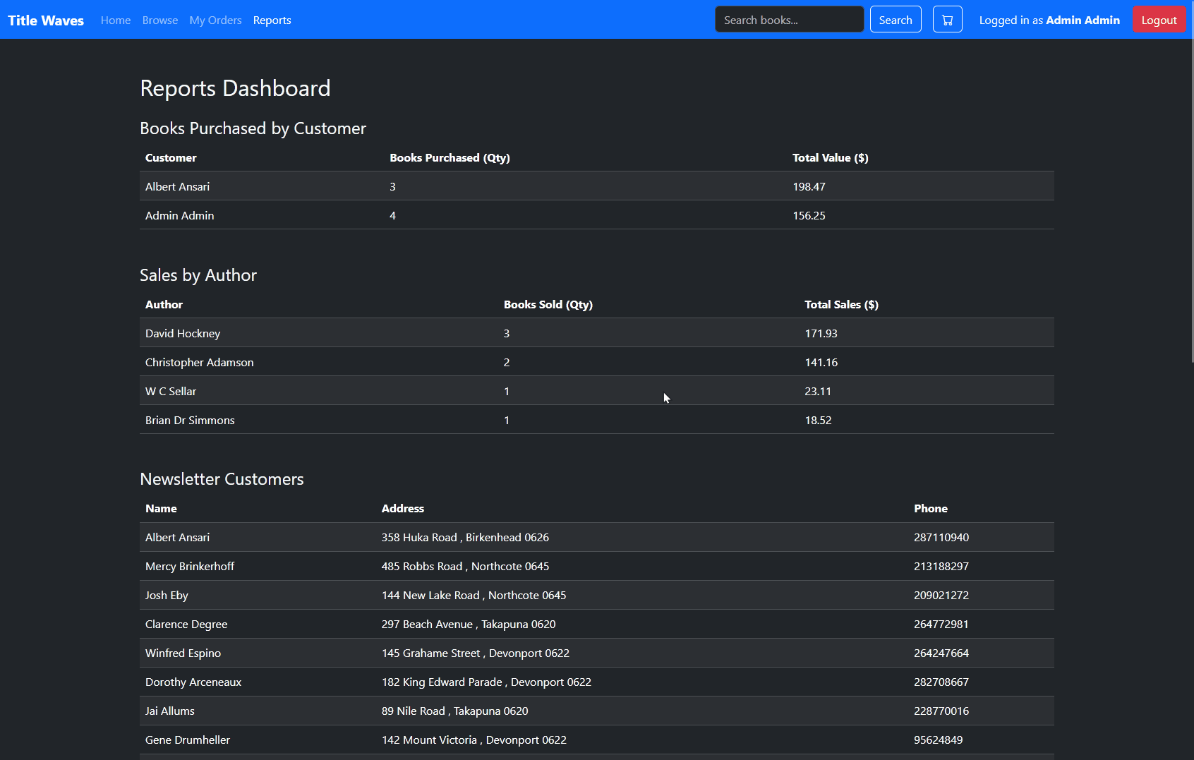

Iterative Improvements/Refinements
As well as testing to ensure the database functions as expected you should improve the database through feedback and cycles of trialing and testing iteratively throughout the design, development and testing process to improve the quality of the database. You should have well established versions of your outcome, each with a changelog on what’s been improved.
You should list milestones and features that you have reached (with screenshots) and evidence on how you have improved it. An example would be a basic text search into a more advanced search that filters out categories.

