92005 - Evidence Template
This is just a template, you can remove the instructions as you add them.
Link to published website:
php.kkc.school.nz/
Describe the purpose and potential users for your outcome
Include what you’re making and how you’re going to do it.
Potential users include those with devices such as phones, tablets, and computers. In order to accommodate all of these potential users we need to make the webpage have responsive design that resizes according to the user's screen size. We will do this by using BS5 to easily incorporate these responsive design elements into our web page
This website will be used to help phil find more customers (potential users) and what i think phil would be looking for in this website is something that makes it easy for potential customers to reach him. A way we would do this is with our design conventions, if pils website is on more devices/browsers we can reach a larger crowd and phil wont lose out on any potential customers
Requirements and Specifications
- All websites should have responsive design in order to be accessible to as many people as possible
- A clear colour scheme that aligns with the subject of the webpage
- A layout/structure that makes sense and provides a logical flow of information
- Compatibility with multiple different types of browsers eg. firefox, edge, safari, internet explorer, etc
Conventions
- Identify the conventions you plan to use in the development of your website. Include links to your research. Then showcase the conventions when you have implemented them.
- Explain how you applied relevant conventions to improve the quality of the outcome
Convention | Explain why we need to consider them | Explain what you’ve done or improved
Responsive Design | “Internet users browse online with both mobile devices and laptops or desktops. Ensure you cater to everybody by using responsive web design to ensure seamless compatibility across all devices and screen sizes.”  Source | Regular CSS and HTML ends up being difficult to use for responsive design without hundreds of lines of code hence why i would use bootstrap 5
Navigation | “A website with intuitive navigation allows people to quickly reach the content they want in a seamless user experience, and 94% of website visitors want easy navigation. Include an always visible navigation bar so people can easily move between pages, no matter where they are on the website.”  Source | Bootstrap 5 has inbuilt styles for things such as navbars etc
Contact Information | “Easy-to-find contact information is a critical component of a business website.”  “it removes barriers to communication, encouraging more engagement and potential business opportunities. Here’s how to effectively integrate contact information into your website.”  Source | A special contacts tab in the website

Wire Frame
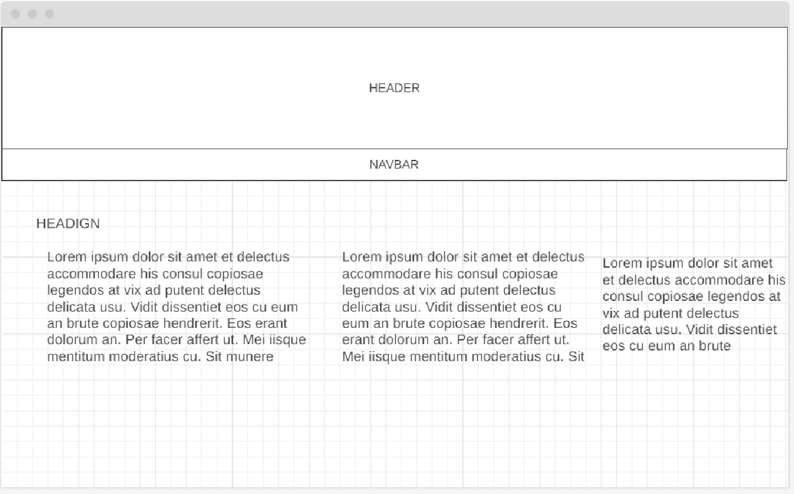
Image and Content Sources
Include any sources for images you have used.
Use of ChatGPT
Used to generate content to fill the webpages
Testing

The page looks like the wireframe on the phone/browser  (Obviously with more colour)  In the screenshots two have been scrolled down to show more content (this is replicated in the wireframe) | 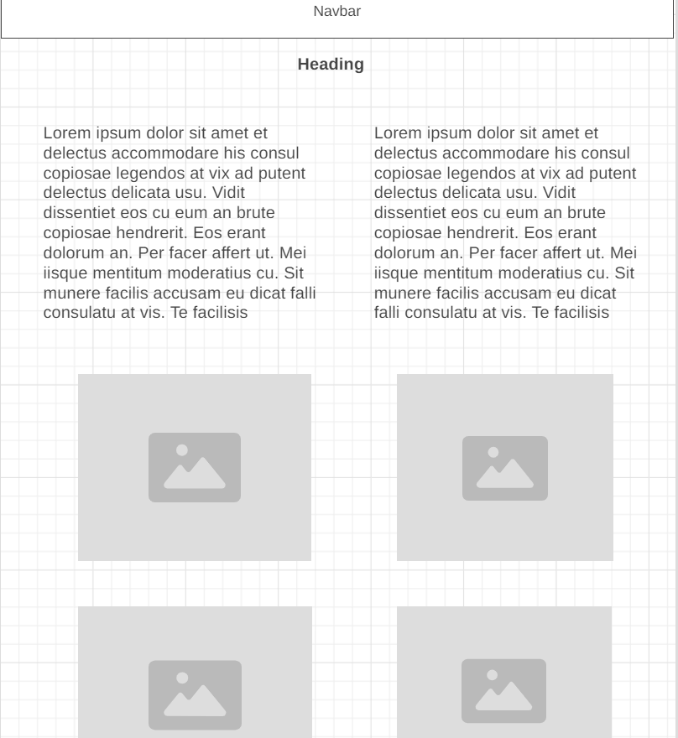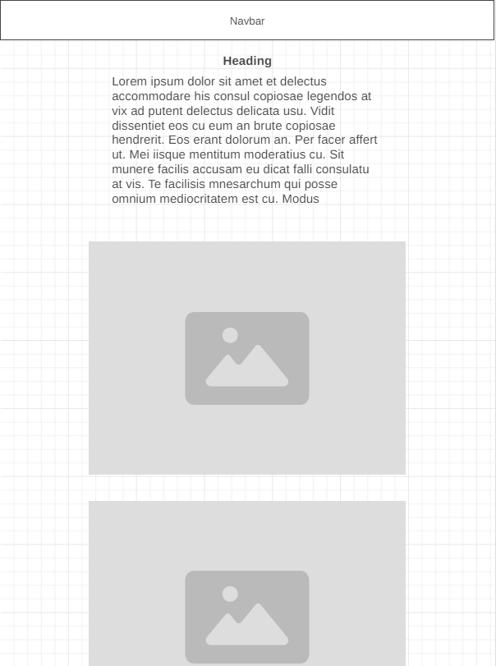 | 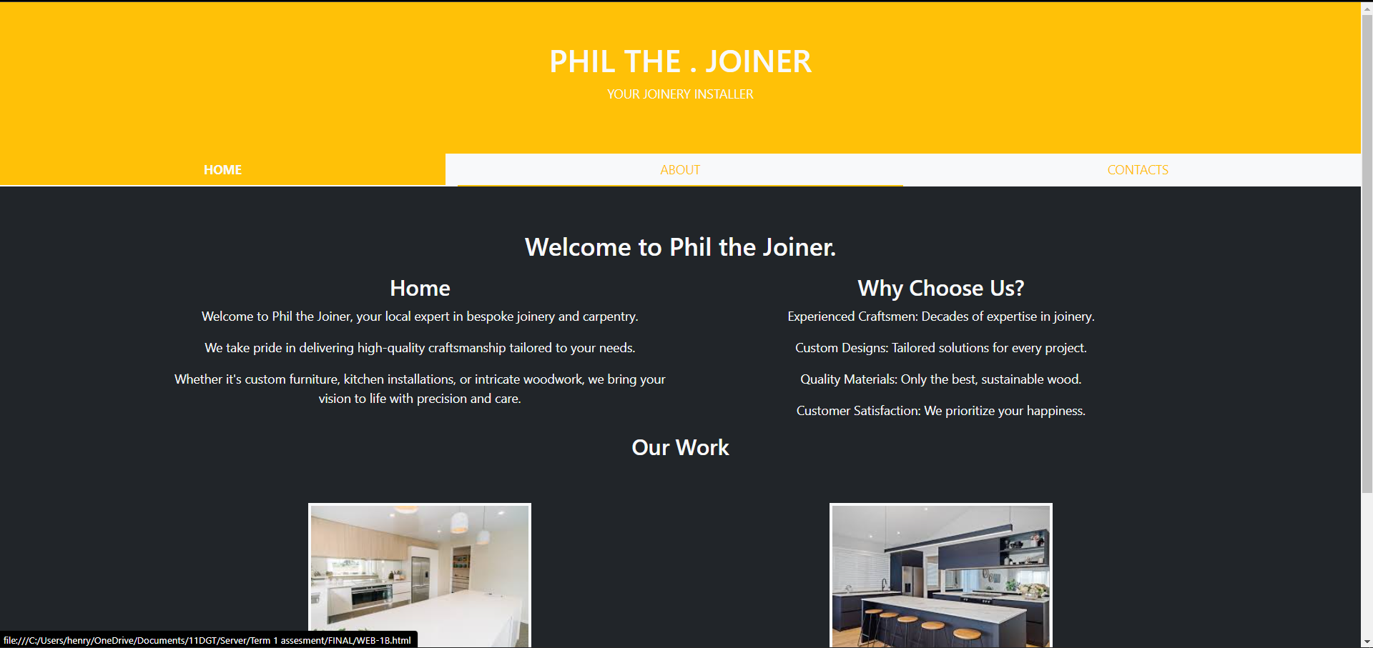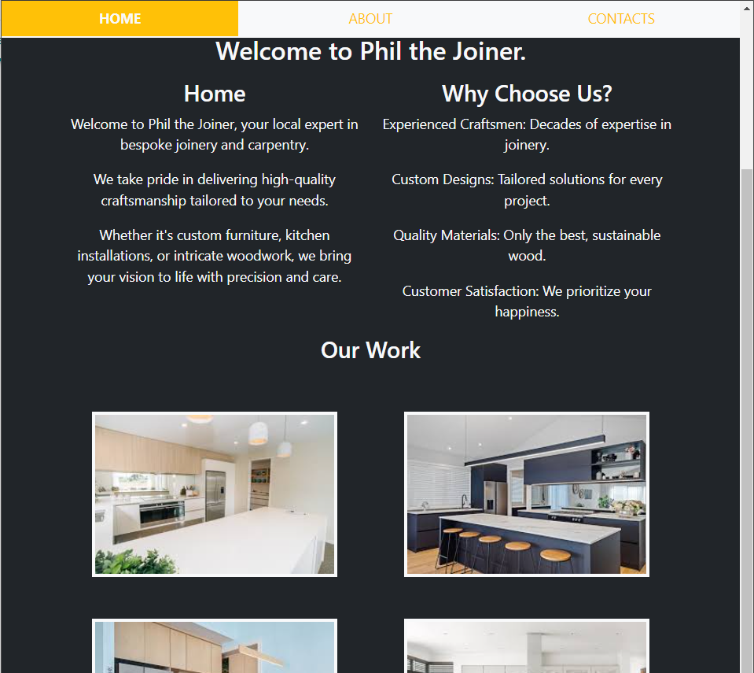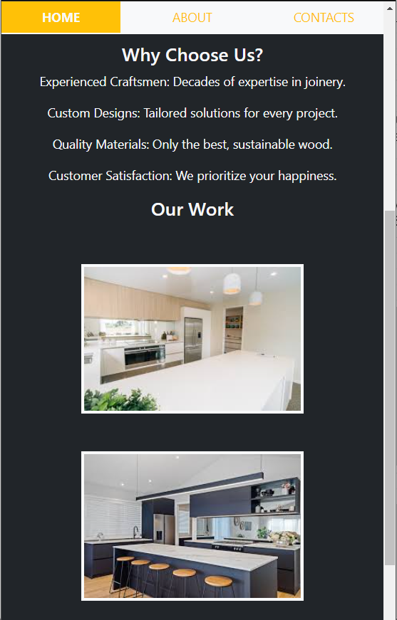
Website looks fine on Chrome/Edge/Firefox
Show how you have tested your site. More cases of testing, the better.
Trialling
Who did you trial the website with? What feedback did you get?

Improvements from Testing and Trialing
Note the changes and improvements you have made. Make sure you explain why! Add more rows as needed.

Before | After and explanation
Regular css/Html becomes finicky and difficult to use which is why i switched to bootstrap 5
Another reason to switch to bootstrap 5 would be because of the ease of use relative to responsive design

Resized (phone)

Resized (tablet)

Regular (PC Laptop etc)
Optimising your outcome

