Quiz Overview

Describe the purpose and topic of your quiz.
Include a list of questions your quiz will have and what inputs the user will need to enter to answer the questions.
The quiz I'm making is the chemistry quiz. What the code does is it will ask the user a random element question, eg. “What is the symbol for the element hydrogen?” and if the user enters the correct answer (H) it will print “correct!”, if the user enters the wrong symbol it will print “sorry you are incorrect” and if the user enters something that is not a element symbol it will print “Invalid input, please enter an element symbol.”

Program Overview

Explain how to run your program.
Describe the variables you have used and what they do for your program.
First save the code in a file, then open that file in spyder. Once the code has loaded, the user can press the green arrow at the top of the screen above the code to start. Please do not edit or delete any code as it will most likely break the quiz. Once the user has clicked the green arrow, the code will run. The program will ask the user if they would like to start. If the user enters ‘no’, then the program will exit. If the user types ‘yes’, the program will ask the user a random element question from the list which the user has to respond with the correct symbol for that element. If the user enters the correct symbol, the program will tell the user that they are correct. If the user enters the wrong symbol for that element, the program will tell the user they are wrong. If the user enters something that is not an element symbol in the list then the program will tell the user that they have entered an invalid input and will move on to the next question. Once the user has answered 5 questions, the program will print out how many the user got correct and if the user got 3 or more correct it will tell the user that they have passed. If the user got 2 or less correct, the program will tell the user that they have failed. The user can also exit the quiz at any time by typing ‘exit’ and the program will instantly quit.
Variables I have used: ‘elements’ which is a dictionary type. It connects the elements to their symbols and the program uses this list to ask the user questions.
‘score’ is an integer and is used to keep track of how many questions the user gets right.
‘total_questions’ is an integer that keeps track of how many questions the user has answered.
‘question_limit’ is an integer that is set at 5 so the program will not ask the user more than 5 questions.

Testing and Debugging Procedures - Expected

Document expected inputs and outputs of the program.
Add more rows as needed.

Expected Input | Expected Output | Actual Output (Screenshot Evidence or copied from console)
if the user inputs the correct symbol to the element. | The program should print "Correct!"
At the start of the quiz the program should ask the user if they would like to begin. | if the user enters yes it will print the first question.
If the symbol user inputs is incorrect. | it should print "Sorry, you are incorrect."
if the user gets a score of 3 or more out of the 5 questions | It will print "Congratulations you passed the quiz!" | 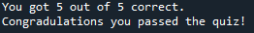
if the user gets a score of 2 or below | It will print "Sorry you have failed the quiz. Please try again."

Testing and Debugging Procedures - Boundary/Edge/Invalid

Document the rest. Make sure to note what type it is..

Expected Input | Expected Output | Actual Output (Screenshot Evidence or copied from console)
Invalid: If the user inputs something that is not a yes or no. | it will print "Invalid input, please type yes or no." The program will repeat the same question until the user enters a valid input. | 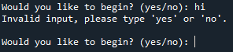
Edge: If user inputs capital ‘NO’ | The program should quit with a message saying "Goodbye!"even though it is in all caps.
Edge: If user inputs capital ‘YES’ | The program should ask the user the first question even though it's in all caps. | 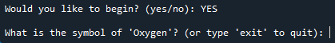
Invalid: If the user inputs an element symbol that is not in the list or something random. | It should print "Invalid input, please enter an element symbol." The program will repeat the same question until the user enters a valid answer. | 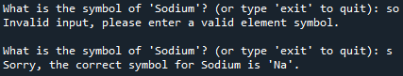
Boundary: If the user inputs an element symbol in this list. 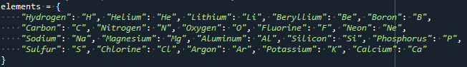 | The program should tell the user either they got the question right or wrong.
Boundary: If the user inputs something that is not in the list. | The program should not accept that and will tell the user that their input is invalid.
Boundary: The program should not ask the user more than what is imputed in the question limit. | If the question limit is set at 5, the program will ask the user 5 questions and the quiz will be over. | 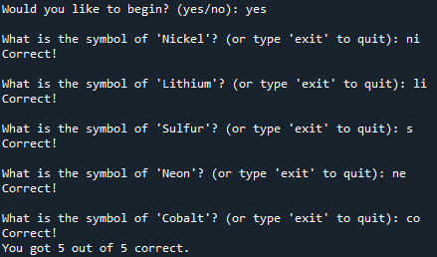
Boundary: if the user gets a score of 3 or more out of the 5 questions | It will print "Congratulations you passed the quiz!"
Boundary: if the user gets a score below the set passing percentage | It will print "Sorry you have failed the quiz. Please try again."
Invalid: If the ‘elements’ dictionary somehow gets deleted. | The program should detect this and tell the user that ‘elements’ has been deleted.

