# 92005 - Evidence Template

### **Link to published website:**

<https://php.kkc.school.nz/11DGT/rj20072/Assesment/zip.file/index%20%281%29.html>

### **Describe the purpose and potential users for your outcome**

Include what you’re making and how you’re going to do it.

**This website is made for Mow ‘N’ Grow Lawn Groomers, The potential users for this Website would be consumers who are in the market for a Lawn Mowing Contractor. The purpose of the website is to give consumers an insight into the company and Our services.**

### **Requirements and Specifications**

A multipage website for Mow ‘N’ Grow Lawn Groomers. That shows customers what services we offer what past jobs look like and how they can get in touch.

### 

### 

### 

### 

### 

### 

### 

### **Conventions**

1. Identify the conventions you plan to use in the development of your website. Include links to your research. Then showcase the conventions when you have implemented them.
2. Explain how you applied relevant conventions to improve the quality of the outcome

| Convention | Explain why we need to consider them | Explain what you’ve done or improved |
| --- | --- | --- |
| All the Webpages look the same (use the same, styles/css) | By keeping all the pages of the website the same (css) and layout is important for making sure users have a smooth experience, with everything looking the same, it's easier for people to get around and understand what they're seeing. | I have ensured that all the webpages have the same layout, using the same color scheme and the same code in (css). |
| Easy to access all different parts of the website | The website needs a way for the user to switch between all the website pages easily and freely. | I added these buttons at the top of the screen to make it easy for users to switch between all parts of the webpage. |
| Contact information in the footer | This makes it super easy for the customers to find contact information no matter what page they are on. This is good because if the user is in a rush to find the contact information this make its quicker and easier for them. | Evedience |

### **Wire Frame**

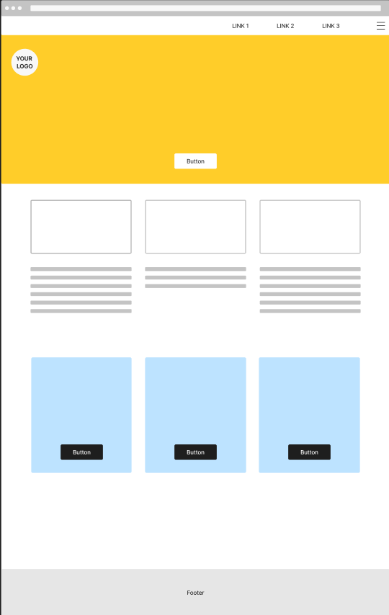

### **Image and Content Sources**

Include any sources for images you have used.

I havent used anything copyrightable or anything from other sources.

### **Use of ChatGPT**

I used Chat GPT for the layout of my webpage/the first page, for the best looking title page and layout possible.

**Tools and Techniques**

I used Figma to make the layout of the webpage. W3schools for testing code and for ideas of what other things I could add to my webpage. Chatgpt for the layout of the first page/home page and the odd bit of code that wasn't working. Notepad++, Google Docs.

**Testing**

Show how you have tested your site. More cases of testing, the better.

|  |  |
| --- | --- |
| The page looks like the wireframe on the phone/browser |  |
| Website looks fine on Chrome/Edge/Firefox | **Edge**  **Chrome**  **Firefox** |

### **Trialing**

Who did you trial the website with? What feedback did you get?

I trialed the website with my Dad. The feedback I got was that I need to add more pictures to show the different mowers and before and after photos of jobs. He said that in the lawn mowing webpage I need to add text about the difference in the mowers (zero turn) (4wd) and what they offer. He also said that I need to add the fact that it's a commercial business so bigger jobs like schools, orchards etc. He also said that the colors are good but he would like the footer green but other than that he likes the layout.

### **Improvements from Testing and Trialing**

Note the changes and improvements you have made. Make sure you explain **why!** Add more rows as needed.

| Before | After and explanation |
| --- | --- |
| When I clicked on the buttons to direct me to the other parts of the webpage it would give me this error code. | Went back and checked all the links to make sure they were all correct and there was a spelling mistake, fixed that and goes to the other part of the webpage. |
| The feedback I got from my dad was that he wanted the names for the other parts of the website changed to match what he offers. | I changed the names of all the other parts of the website to match what he offers. |
| I used to have a nav bar with icons but didnt i didnt like having a navbar i thought that it took up too much space and made the banner look worse than without a navbar. | Instead i have a banner with a button which put the user down to the buttons that send the user to the other parts of the webpage.I chose to do this because it gives the webpage a planer look and doesnt take away from the point of the webpage. |
| I had no footer on the main webpage which i decided to change because the page just goes to white and it needs something to show the webpage doesnt go down any further. | I added a footer which is the exact same colour as the banner so it all ties in. |

### **Optimizing your outcome**