Quiz Overview

Describe the purpose and topic of your quiz.
Include a list of questions your quiz will have and what inputs the user will need to enter to answer the questions.
My quiz is a "higher or lower" game that quizzes player's knowledge on their favourite Twitch streamer's earnings. The goal is to guess whether the earnings of one streamer are higher or lower than another.

Quiz Questions:
- Question: "Do you think streamer B earned higher or lower than streamer A?"
  - Input: You type "h" for higher or "l" for lower.

Program Overview

Explain how to run your program.
Describe the variables you have used and what they do for your program.
How the Program Runs:

Execution: Run the program in Spyder. The quiz will start automatically with a welcome message.
Instructions: The player will be shown the earnings of one streamer and asked to guess if the next streamer earns more ("h") or less ("l").
Quiz feedback: the program informs the player if they were correct and displays the correct earnings if they were wrong.
Score Display: At the end of the quiz, the player’s score is displayed with a pass/fail based on their performance.
Replay Option: The code will ask the player if they want to play again if the player types "yes" or "y", the quiz restarts.

Variables Used:
- streamers: A list of a streamer's name and earnings.
- score: An integer tracking the number of correct answers the player gets.
- num_questions: An integer representing the number of questions in the quiz, determined by the length of the streamers list minus one.
- response: The player's input ("h" or "l") for each question.
- correct_answer: Stores the correct answer ("h" or "l") for comparison against the players response.
- play_again: Stores the players input to decide if they want to play the quiz again.

Testing and Debugging Procedures - Expected

Document expected inputs and outputs of the program.
Add more rows as needed.

Expected Input | Expected Output | Actual Output (Screenshot Evidence or copied from console)
Player types "h" when the next streamer earns more | "Great job you got it correct!" message and score incremented | 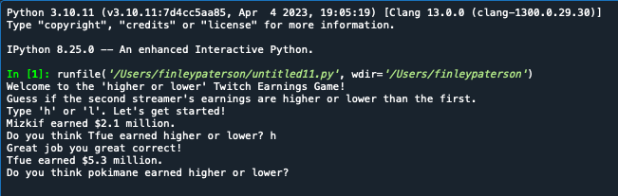
Player types "l" when the next streamer earns less | "Great job you got it correct!" message and score incremented | 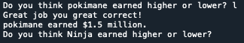
Player types "h" when the next streamer earns less | "Sorry you are wrong!" message with correct earnings displayed | 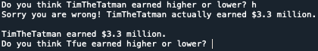
Player types "l" when the next streamer earns more | "Sorry you are wrong!" message with correct earnings displayed | 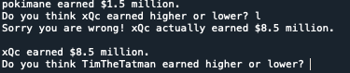
Player completes quiz with more than 50% correct answers | "Congratulations you passed, you win nothing :)" message | 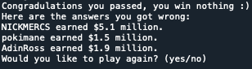
Player completes quiz with less than 50% correct answers | "Come on, Lock in." message | 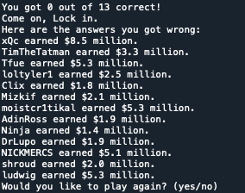

Testing and Debugging Procedures - Boundary/Edge/Invalid

Document the rest. Make sure to note what type it is..

Expected Input | Expected Output | Actual Output (Screenshot Evidence or copied from console)
User enters something other than "h" or "l" | Program should register the input as incorrect answer | 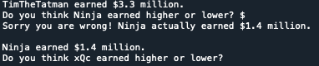
User doesn't input anything and just presses Enter | Program should handle empty input as incorrect answers | 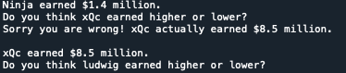
User enters a valid answer but in uppercase | Program should accept "H" or "L" as valid inputs | 