92005 - Student Documentation

Link to published website:

https://php.kkc.school.nz/11DGT/ko24009/vs%20code%20assesment/v1/assesment/how.html

Describe the purpose and potential users for your outcome
My website is used for learning how to skimboard, potential users would be anyone that wants to learn how to skim board

Requirements and Specifications
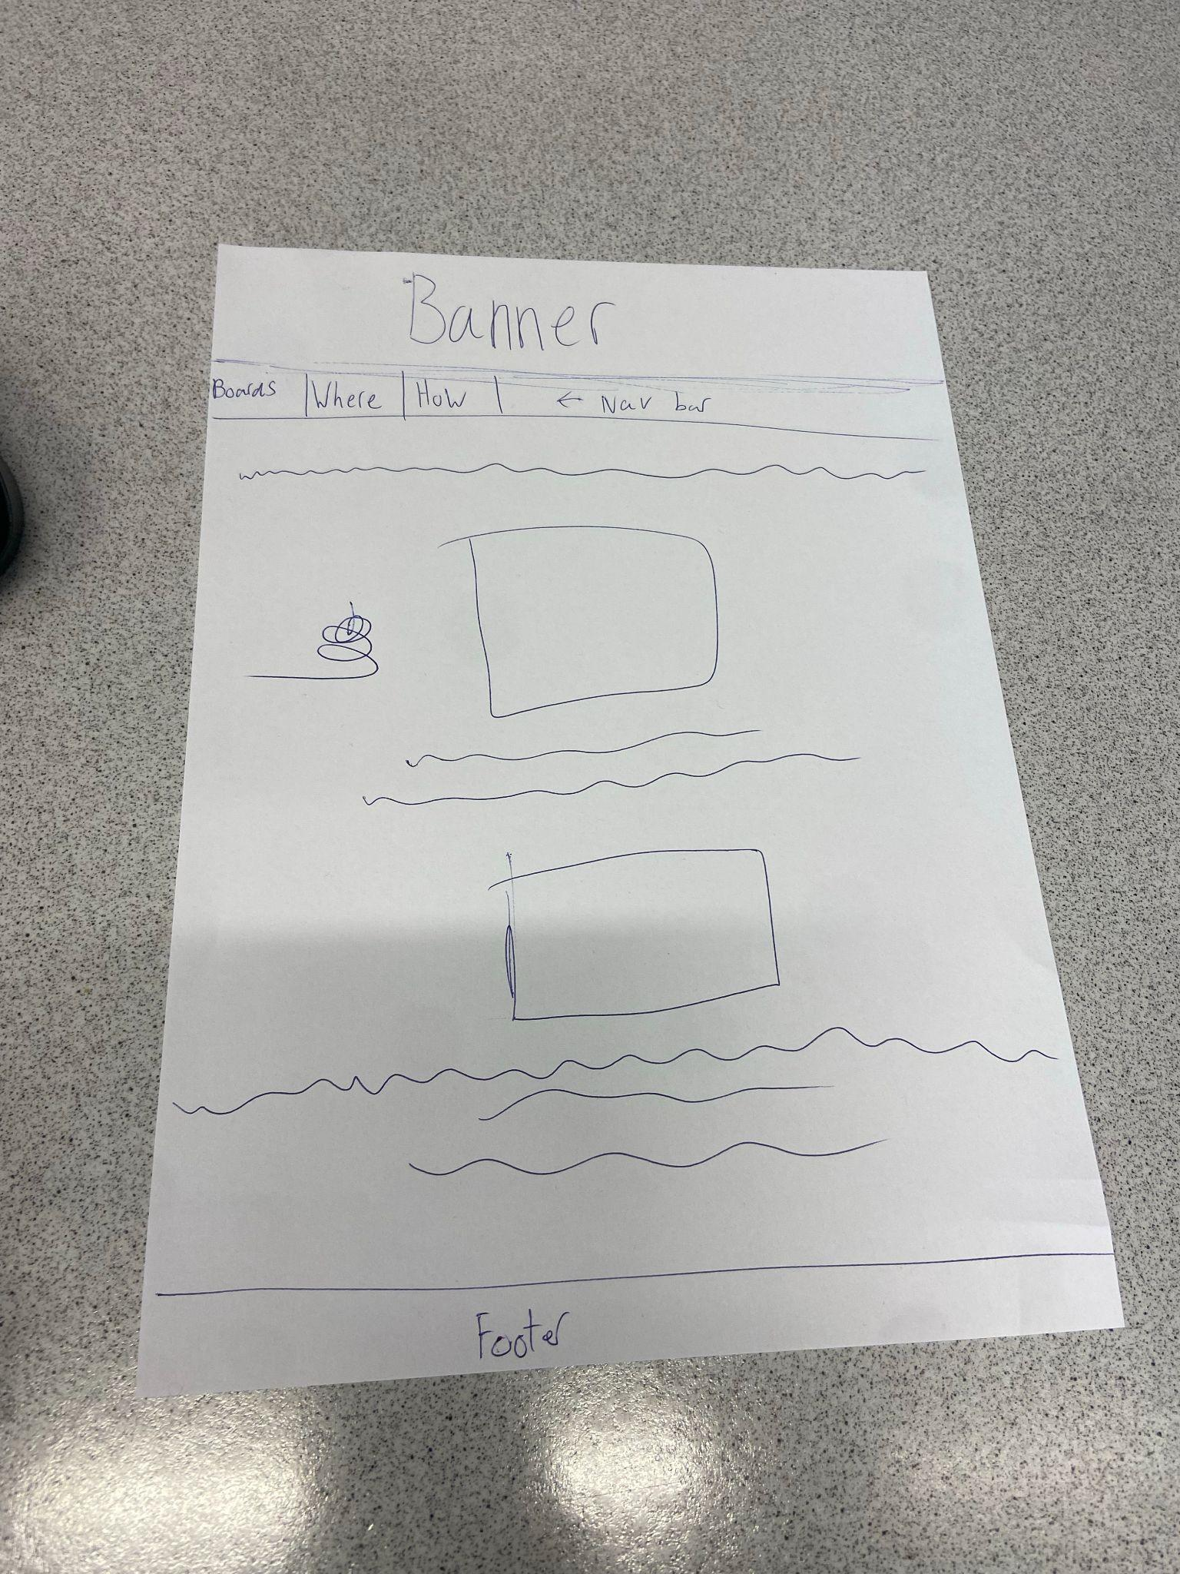
The website needs to have photos to explain the different board shapes, the type of terrain that is needed and , the website needs to have information on all kinds of skimboarding and all the aspects.

Wire Frame –

Tools and Technique
Vs code for the coding
Coded in html
Pictures are from google

Image and Content Sources
Google for the images
I made the banner in photopea

Testing

Using the contrast checker to make sure text is readable | 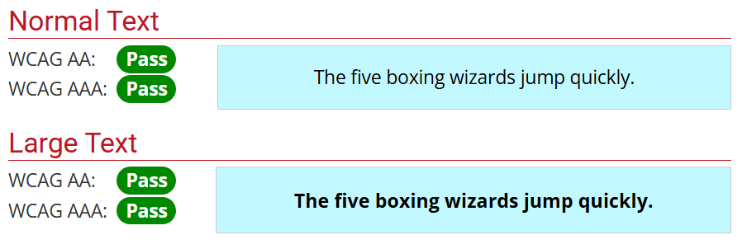
Testing all the links in nav bar works | 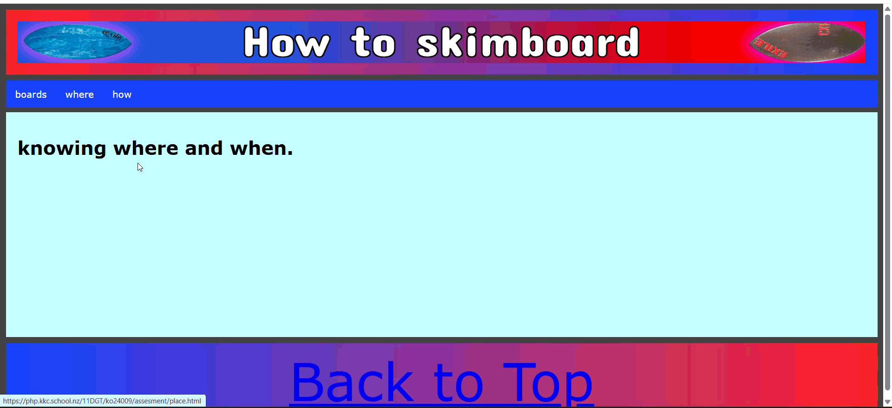
Making sure text is proofread and spellchecked. | I used google docs to spell check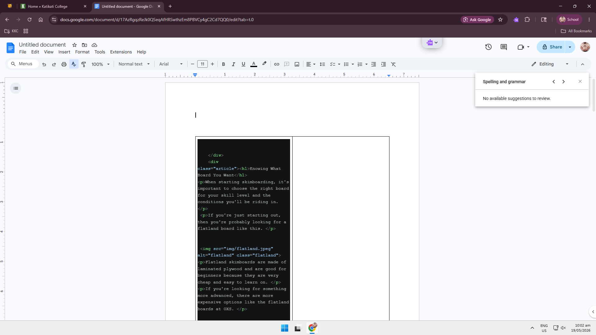
Testing the website is uploaded and can be accessed | https://php.kkc.school.nz/11DGT/ko24009/vs%20code%20assesment/v1/assesment/how.html

